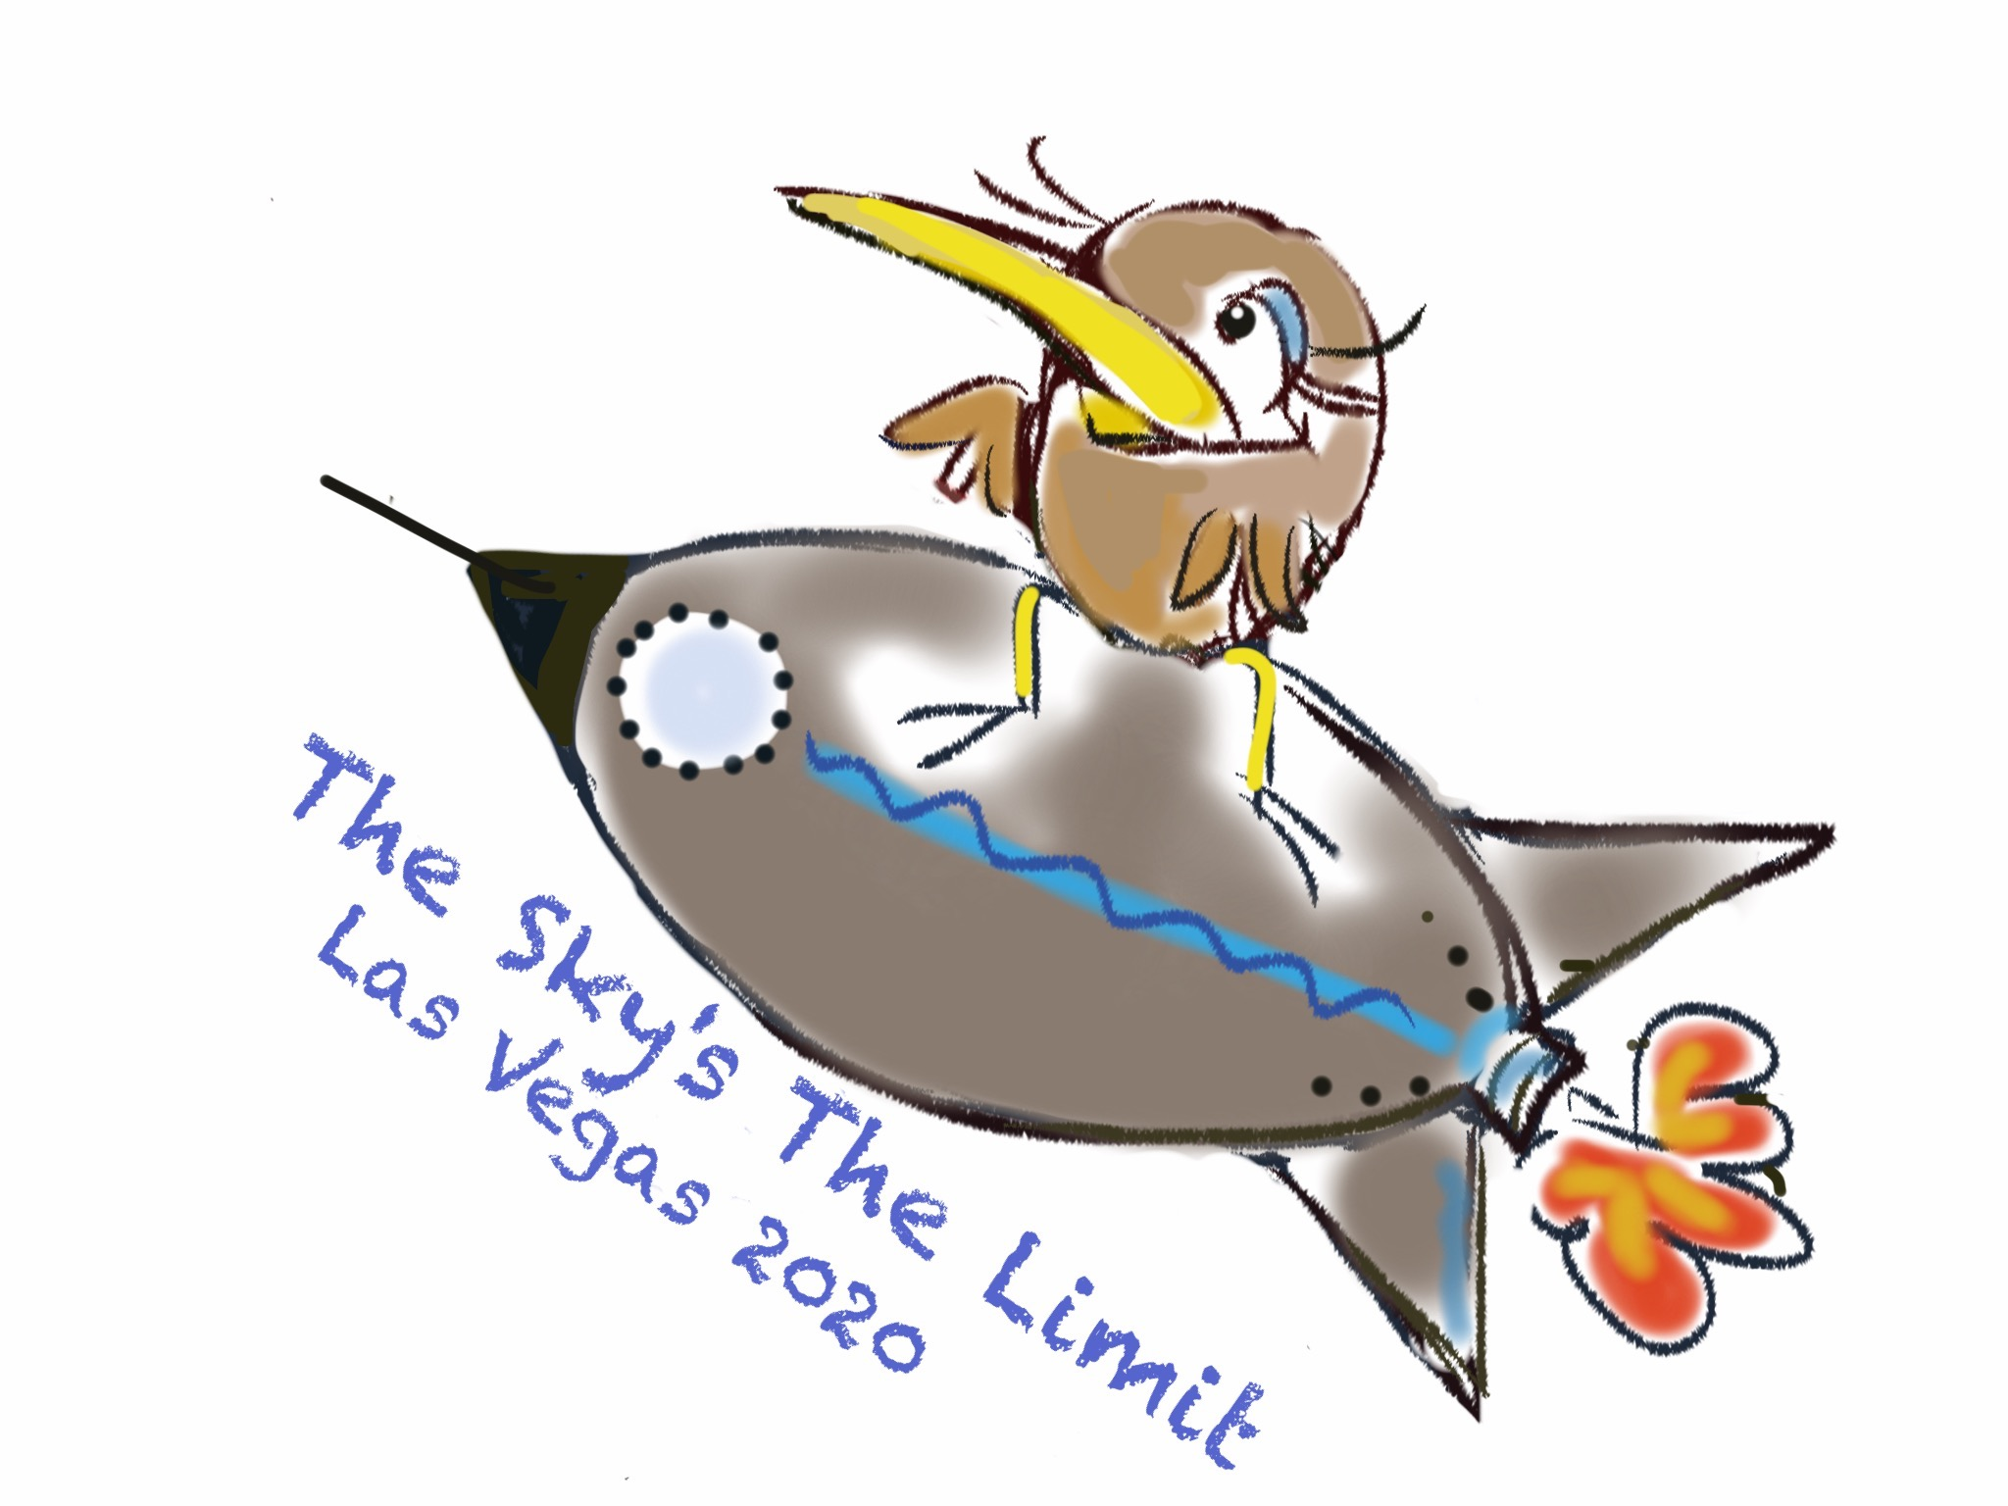

“The Sky’s The Limit”
The Kiwi Club
Convention 2020 – Las Vegas
Boutique Reservation

Chapter or Individual:______________________________________________________________________

Chapter or Individual Contact: Phone number, email address

______________________________________________________________________________

Phone # Email

Table rental fee: $50.00 (Chapters-no charge). Make checks payable to The Kiwi Club.

List Items to be sold (if possible attach photo)

Rules and Regs:
-You must be a (dues paid) member of The Kiwi Club to participate in Boutique.
-Absolutely NO designer “knock offs” (Chanel, Vuitton, Gucci etc.)
-No raffles
Registration deadline March 1, 2020. Send registration form and check (if applicable) to:
Mary Thrasher
Boutique Chairman
21 Briarwood Lane
Palatine, IL 60067
Phone: 847-397-1431, email: mthrasher21@comcast.com

-Table signage will be provided.
-Set up on April 28, from 8:00AM-12:00PM
-Boutique will be closed and doors locked during Kiwi functions and at the end of the day.

