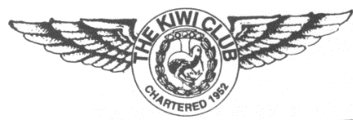
THE KIWI CLUB

APPLICATION FOR MEMBERSHIP FORM

Name: Date:
First Maiden Last

Address:
Street Apartment City State ZIP

Phone: Email:
Home Cell Alternate

Emergency Contact:
Name Relationship Phone

Airline Affiliation if other than AA:
USAir TWA America West TransCaribbean Reno Air American Eagle Contracted American Envoy

Did you retire from AA? Yes No If so, give year of retirement.

Graduation Year/Class Number: Birthdate (year optional):

Have you been a member of The Kiwi Club in the past? Yes No If so, list chapter affiliation or if you were a member at large (if you were a member of more than one chapter, list all):

Would you like information about a chapter? If so, click on the Membership link and Chapter Map, find the chapter(s) you are

interested in and list here:

Please include your check in the amount of $50.00 (U.S. currency made payable to The Kiwi Club) with your application. This amount covers the current two-year term. Mail your check to the sitting National Treasurer (see list of National Officers for contact information).

National dues should be paid prior to November 1st; dues received after November 30th are delinquent, and a fee of $5 will be added to your membership fee.

Revised 1/5/2022

