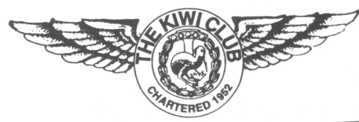
THE KIWI CLUB
NATIONAL ENDEAVOR REPORT FORM

When reporting donations made to Wings Foundation, please do not include monies paid out from your chapter treasury to purchase items used in raffles, auctions, sales, etc., to raise money. This money is not a donation, but your chapter’s expense. If you would like to include what you paid for any items or time spent in raising the money, you may include them in your description – do not include them as a donation.
Please do not confuse this report with the Chapter Charitable Activity Report due at the end of each term by any chapter wishing to be considered for a Kiwi award.

Date of Report:

Chapter Name:

Chapter President:

Report submitted by: Office Held:

Address:
Street/Apt City State Zip

Phone (include Area Code): Email:

Dollar Amount Submitted:

Brief description of event(s) held to raise money for Wings:

Make checks payable to Wings Foundation, Inc. Send the checks and report no later than December 15, 2020, to the National Treasurer:

Vicki Kabal, The Kiwi Club National Treasurer AND A COPY OF REPORT TO: Kathy Kridel, Endeavor Coordinator
7s201 Berry Court 3920 Mariners Way
Naperville IL 60540 Cortez, FL 34215
KiwiNationalTreasurer@gmail.comvjkubs@gmail.com kiwipres34@gmail.com

Thank you for your support of The Wings Foundation, The Kiwi Club’s National Endeavor.

For National Endeavor Coordinator’s Use Only:

Date report and check(s) received by Coordinator:

No. of checks received:

Total amount received:

Date check(s) sent to Wings Foundation:

Revised 9/20 gmp

